Team-Based Learning in: “Construction Engineering and Management”

Note: This summary was drawn from an interview with the Centre for Instructional Support and Dr. Froese, as well as a review of materials used for his class. We have written it in the first person to make it easier to read.

- Course Situation
- Department: Applied Science
- Subject: Civil Engineering
- Level: Civil 400 Construction Engineering and Management, 4th year course
- Students: N = 106, required course for civil engineers
- Time Structure: two one and a half hour sessions each week.
- Any special course or classroom factors?: 100 person, tiered lecture theatre with fixed seating
- Learning Goals for the Course
- The construction industry is the “production” phase of virtually all civil engineering work. The goal of this course is to familiarize students with the construction industry—including the industry as a whole, construction companies, construction projects, and individual activities.
- Our main point of view was that of someone working for a construction company in charge of managing a project: i.e., a Project Manager. However, the material applies to anyone involved in construction projects (e.g., designers, owner’s representatives, site engineers, etc.)
- Gain an understanding and experience of the issues they will encounter in the construction industry
- Explore the interdependencies between different players in the construction industry.

- Reasons for Changing to Team-Based Learning
- Previous way of teaching: lectures with some case studies and take home group assignments
- Problems encountered: pace of lectures was too slow
- I had taught the course for 12 years and accumulated many anecdotes and examples but this resulted in having too many details to convey and it was hard for students to take it all in.
- I felt coverage of topics could be more condensed
- What made you think that team-based learning might be an alternative worth trying? Course was already in 3 or 4 modules. Students didn’t like the text book, too superficial, but I had given weekly online quizzes based on the text each week and this definitely seemed to encourage preparation. As well, the year before I used a web-based computer game to demonstrate the bidding cycle – although the game was riddled with bugs and ended giving all the wrong calculations the students absolutely loved playing with it – I could tell they loved the hands on aspect. The homework assignments often involved group activities and these sometimes spilled into class time, students were more engaged and interested with these projects.
- Changes Made
- Changes made: Organized class into 5 basic modules and left one module as a traditional format that would be taught by a guest lecturer.
- Decided not to get rid of lectures all together, condensed lecture information down to one lecture per module.
- Chose a new text that was online and more appropriate for the class
- Organized notes, PowerPoint slides and chapters into reading resources for each module.
- Created quizzes for each module. This is what took the extra time considering I had a new textbook and wanted to link the questions more to the readings than to my lecture for each module.
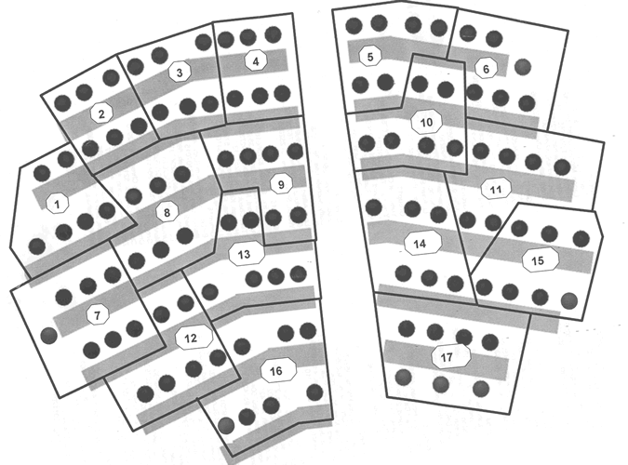
- Used WebCT to collect student information at the beginning of course for creating groups, to deliver the reading materials for each module, and the surveys for course evaluations half-way through the term as well as peer evaluations at the end of class.
- Created a seating plan (shown on right). Since the class had 100 fixed seats and I had 106 students I needed to make sure everyone had space. I added chairs at the end of rows and gave each group its own territory.
- Results: (in terms of the general operation of the course). Each module spanned 5 classes. In the first class of each module I gave a 1.5 hour lecture. The second class included the individual and group Readiness Assessment Tests (RATs). I referred to these as Quizzes but, on reflection, I think Larry Michaelsen’s advice was right, that by calling them RATs or RAPs I emphasize student’s responsibility. The Readiness Assessment Process did not include an appeals process. I gradually used Scantron sheets and then the IF AT forms for the group quizzes. With each change I noticed more discussion and interaction. The immediate feedback also gave me more information to shape my mini-lectures, I knew more about what was understood and what needed to be clarified.
- The third and four class of each module used the examples I had previously been using in lectures, but altered to work as application assignments. Students applied estimating formulas, represented different corporate perspectives and worked on larger case studies where they had to provide solutions to problems encountered. There was a guest speaker for the fifth and final class of each module. The five modules included:
- Overview of Project Management and the construction industry: the major elements of project management; characteristics and segments of the construction industry; participants, roles, and relationships; project lifecycles. (10hr)
- Project Delivery and Contracting: project delivery alternatives and contracting procedures; (8 hr)
- Estimating: preliminary and detailed estimating techniques. (8 hr)
- Scheduling and Other Aspects of Project Management: Project scheduling; elements of risk management, quality management, safety, etc. (8 hr)
- Managing People: managing human resources in engineering.(6 hr) – guest lecturer.
- Examples of Team Assignments
- One very effective group activity was the week long Computer-based Simulation Game called “Super Bid Simulator” where students had to work in teams and take on the role of General Contractors (GC) and are expected to operate their own company accordingly. Each GC is required to account and monitor their financial status recording all transactions, expenses and income of the company. The first part of class was used to demonstrate how the game worked and the last half was used for each team to determine their bidding strategy. The bidding cycle continued throughout the week and the team assigned a person each day to check out the website and bid according to their strategy.
- Another application activity required students to read through the specifics of a case study and determine the major criteria to consider in bidding for these construction projects, the advantages of main delivery options and then make a choice as to the delivery option they would recommend. While teams did a show of hands to demonstrate their choice more discussion could have happened at this stage to encourage commitment to their decision and discussion between groups. The students’ responses were followed up with the actual decisions of the community in the Case Study.
- Another case study outlined several different viewpoints of the project’s history and current status in the form of interviews with key players, giving some insight into both the project itself and the local industry as a whole. Students are asked to individually prepare a list of problems facing the project and the industry, then as a team answer the questions which follow the case. Teams prepared a diagram that showed the project’s organizational structure and paths of information flow, indicating which areas represented the underlying causes of each of the problems. Teams were also to suggest possible solutions to each of the problems identified as well as cost estimates for these proposed changes.
- Impact
- On Student Learning and Performance:
- Used the same exam as the previous year and marks with TBL were a bit lower, but not by a statistically significant difference. It is tempting to think that it is easier to study with lecture format notes, that lectures present material more logically – but a more important question is whether students will remember the information a year from now.

- On Student Attitudes
- Students enjoyed the course a lot more
- Teaching evaluations up by .7 on a four-point scale
- Students were receptive, gave no resistance and engaged in lively discussions.
- These are interesting results considering the same group of students, the previous year, had been in another class which used group work with disastrous results. In contrast I addressed their concerns about group work and provided incentives.
- On the Teacher
- The year was much more fun to teach.
- Lecturing in condensed form was easier.
- I got through most of the same amount of material. The TBL approach required that I have a bit narrower scope, some stuff gets missed but I felt more successful at conveying material.
- Even though this was the last year I was teaching this course I believed that TBL was worth the effort to make the learning process more active and provide students with an opportunity to engage with the real-world problems they will encounter in the construction phase of civil engineering.
- As an aside I started each class with a funny video clip from my collection of humorous advertising which I could tie into each topic. This set a nice tone for the class and students began contributing their own video clips - as time went by it was a challenge to find a corny segue. Formally it didn’t have anything to do with the class but it couldn’t have hurt and probably helped.
- Related Publications
- None as yet
- Contact Information
Dr. Thomas Froese
Phone: 604 822-2027
Email: tfroese@civil.ubc.ca

- APPENDIX: More Detailed Information about Team Assignments and Products of the Teams’ Work
- Project Delivery Modes – case study application activity.

